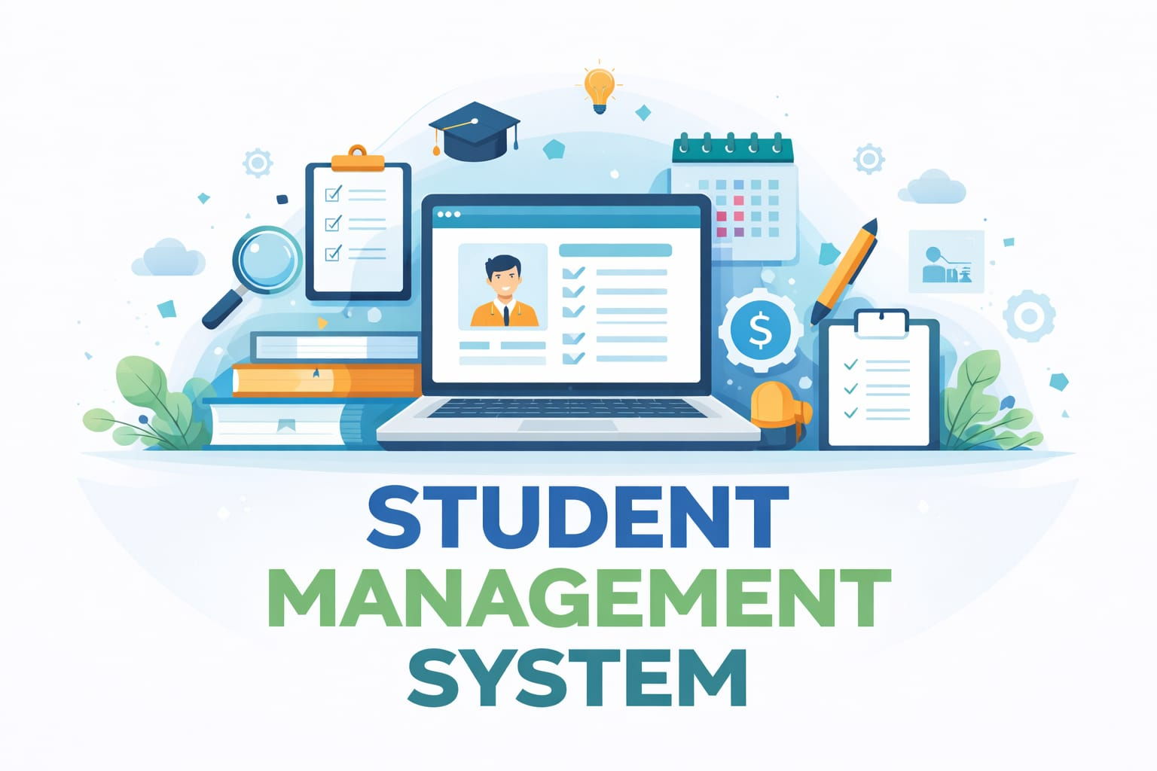

TEAM MEMBERS

1.Nalabati H S N S Vaishnavi(team lead) -25A31A0585
2.Nallajarla Venkata Naga Sai Lakshmi Kavya-25A31A0586
3.Nalla Kashyap Shrivatsa - 25A31A05AT
4.Penneddy Veera Venkata Satyanarayana-25A31A05AU

GUIDED BY

Mrs.T.N.V.Durga
Assistant Professor
CSE Department
Pragati Engineering College (A), Surampalem

Project Description
The Student Management System is a C++ based application developed to maintain and manage student records in an organized and efficient manner. This project uses a linked list data structure to store the data dynamically, which makes it suitable for operations where records need to be frequently inserted, updated, searched, and deleted. The system is designed around the basic CRUD operations: Create, Read, Update, and Delete, which are the foundation of most record-management applications.
In this project, each student record is represented as a node in the linked list. Every node contains important details such as student name, roll number, course, marks, contact information, or any other required fields. The nodes are connected using links, allowing the program to store records in a flexible way without needing a fixed size array. This makes the system efficient when handling a growing number of student entries, since memory is allocated only when a new record is added.
The Create operation allows the user to add a new student record into the system. When a record is created, a new node is dynamically allocated and inserted into the linked list. The Read operation displays all stored student details in a proper format, making it easy for the user to review the available data. The Update operation enables modifications to an existing student record, such as changing the student’s name, marks, or other details. The Delete operation removes a student record from the list when it is no longer needed. These four operations together make the system complete and practical.
This project is usually implemented in a menu-driven format, where the user can choose actions through simple console commands. Such an interface makes the program easy to understand and operate, even for beginners. The menu may include options like add student, display all students, search student, update student, delete student, and exit. The search function is often included to find a specific student using a unique key such as roll number or ID.
The use of linked lists in this project provides several advantages. Unlike arrays, linked lists do not require a predefined size, so the system can grow as needed. Insertion and deletion are also easier because elements do not need to be shifted in memory. This makes linked lists a good choice for applications where records are modified frequently. At the same time, the project helps students understand important programming concepts such as pointers, dynamic memory allocation, structures or classes, and data traversal.
This project is not only useful for managing student data but also serves as an excellent learning tool. It helps students apply theoretical knowledge of data structures to a real-world problem. By building this system, one can improve problem-solving skills and gain a better understanding of how linked lists work in practical software development. The project also demonstrates how a simple console-based program can be used to manage information in a systematic way.
Overall, the Student Management System using Linked List in C++ is a simple, efficient, and educational project that showcases the implementation of CRUD operations in a dynamic data structure. It is a good example of how programming concepts can be used to build useful applications for record management.

Features
- Add new student records dynamically.
- Display all stored student records.
- Search for a student using roll number or ID.
- Update existing student information.
- Delete unwanted student records.
- Manage data without using a fixed-size array.
- Use linked list traversal for record handling.
- Provide a simple menu-driven user interface.

Objective
The main objective of this project is to develop an efficient student record management system using linked lists in C++. The project aims to demonstrate the implementation of CRUD operations and to show how dynamic data structures can be used for storing and managing records effectively.

Conclusion
This project is a practical example of how linked lists can be used in C++ to build a functional student management application. It is simple enough for beginners, yet detailed enough to demonstrate important programming concepts and data structure usage.

SYSTEM ARCHITECTURE
Student Management System using Linked List (CRUD)
Architecture Components
1. User Layer
Interacts with system
Inputs:
Student ID
Name
Marks
Selects operations from menu
2. Interface Layer (Menu System)
Displays menu options
Handles user choice
Passes request to logic layer
3. Functional Layer (CRUD Modules)
This layer is divided into modules:
Add Module (Create)
→ Creates new node
Display Module (Read)
→ Traverses linked list
Search Module
→ Finds student by ID
Update Module
→ Modifies student data
Delete Module
→ Removes node

4. Data Management Layer (Linked List)
Stores all student records
Structure:
ID
Name
Marks
Next pointer
Uses:
Head pointer
Dynamic memory
5. Output Layer
Displays results:
Student details
Success/failure messages

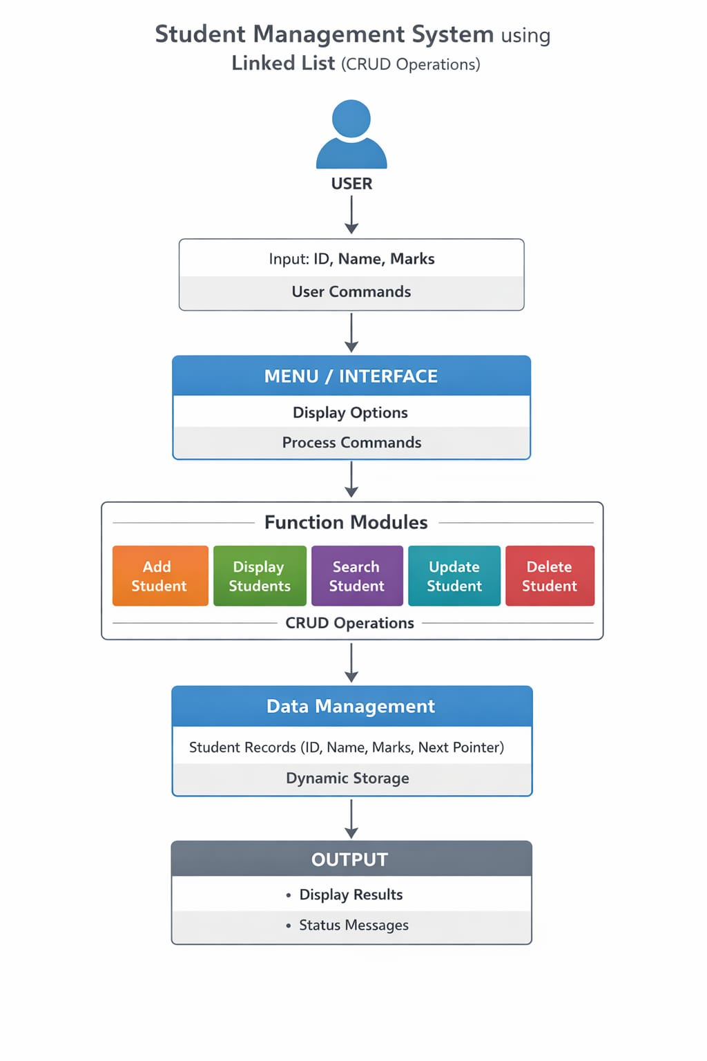

ALGORITHM
Student Management System (CRUD using Linked List)

Step-1: Start the program

Step-2: Define a node structure
Create a structure with fields:
student ID (integer)
name (string)
marks (float/integer)
next (pointer to next node)

Step-3: Initialize the linked list
Declare a pointer head
Set head = NULL to indicate the list is empty

Step-4: Display menu
Add Student
Display Students
Search Student
Update Student
Delete Student
Exit

Step-5: Read user choice

Step-6: Add Student (Create)
Create a new node using dynamic memory allocation
Read student ID, name, and marks
Assign values to the node
Set next pointer to NULL
If head == NULL → assign new node to head
Else:
Traverse the list to the last node
Link new node at the end

Step-7: Display Students (Read)
If head == NULL → display “No records found”
Else:
Traverse the list
Display student details for each node

Step-8: Search Student
Read student ID to search
Traverse the linked list
Compare each node’s ID with input
If found:
Display student details
Else:
Display “Student not found”

Step-9: Update Student
Read student ID
Traverse the list
If found:
Modify student details (name/marks)
Else:
Display “Student not found”

Step-10: Delete Student
Read student ID
Traverse the list
If found:
Remove node from list
Adjust links properly
Else:
Display “Student not found”

Step-11: Exit
Stop the program

Step-12: End

